**NAME**………………………………………. ………ADM NO:…………………

CLASS ……………..…DATE: ……….……….……

**231/3**

**BIOLOGY**

**PAPER 3**

**(PRACTICAL)**

**JULY 2024**

**TIME: 1 $3/{4 }$ HOURS**

**SULIMO JOINT EXAMINATIONS 2024**

***Kenya Certificate of Secondary Education (K.C.S.E.)***

**231/3**

**BIOLOGY**

**Paper 3**

**1 $3/{4 }$ HOURS**

**INSTRUCTIONS TO CANDIDATES**

1. Write your name and Adm. number in the spaces provided above.
2. Sign and write the date of examination in the spaces provided above.
3. Answer **all** the questions in the spaces provided.
4. You are required to spend the first 15 minutes of the 1¾ hours allowed for this paper reading the whole paper carefully before commencing your work.
5. Additional pages must **not** be inserted.
6. **This paper consists of 5 printed pages**
7. **Candidates should check the question paper to ascertain that all the pages are printed as indicated and that no questions are missing.**
8. **Candidates should answer all the questions in English.**

**For Examiners Use Only**

|  |  |  |
| --- | --- | --- |
| **Question** | **Maximum score** | **Candidate’s score** |
| 1 | 12 |  |
| 2 | 15 |  |
| 3 | 13 |  |
| TOTAL | **40** |  |

1. You are provided with specimen **R** (raw banana), a scalpel blade, Liquid **A** and Liquid **B**

1. Giving a reason, name the type of fruit represented by specimen **R**. (2 marks)

Type:…………………………………………………………………………….………

Reason:……………………………………………………………………………………………………………………………………………………………………………….

* *Remove a peeling from specimen* ***R*** *leaving the fleshy part.*
* *From the peeling, cut a piece measuring about 3 cm long along the length of the peeling and 1 cm wide.*
* *Slice the piece by cutting along its length to obtain* ***4*** *equal strips of about 3cm long.*
* *Into separate beakers, immerse two strips in liquid* ***A*** *and the other strips in the liquid* ***B****.*
* *Leave the set-up for 30 minutes. Remove the strips and compare their flexibility.*

1. Record the observations made in the strip immersed in: (2 marks)

i. Liquid **A**.........................................................................................................................

............................................................................................................................................

ii. Liquid **B**.........................................................................................................................

.............................................................................................................................................

1. Account for the changes in flexibility in the strip immersed in liquid **A.** (2 marks)

....................................................................................................................................................................................................................................................................................................................................................................................................................................................................................................................................................................................

1. Draw and label a diagram showing the appearance of the strip immersed in liquid **B.**  (3 marks)
2. Account for the changes in shape of the strip immersed in liquid **B.**  (2 marks)

....................................................................................................................................................................................................................................................................................................................................................................................................................................................................................................................................................................................

1. How can a control experiment for this experiment be set? (1 mark)

............................................................................................................................................

.............................................................................................................................................

2. (I) The photographs below show bones obtained from different regions of a mammalian body. The photographs are in different views. Use the photographs and **specimen Z** to answer the questions that follows.

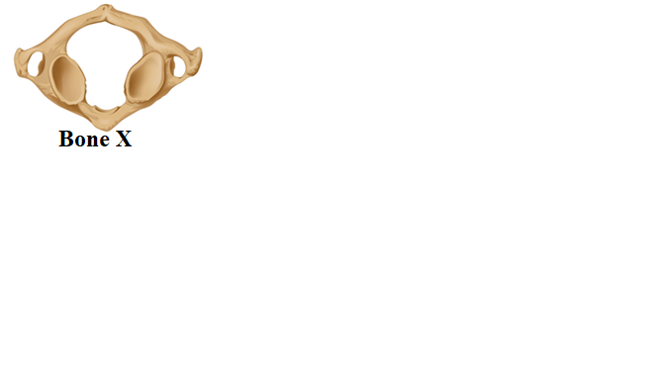 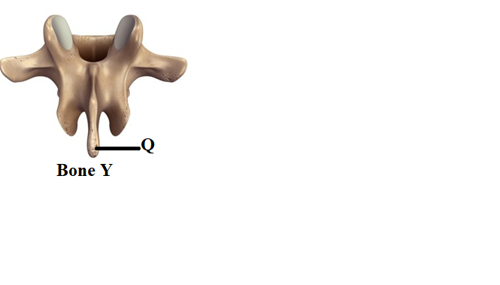

1. Identify the bones **X** and **Y** (2marks) **X**………………………………………………………………………………………

Y………………………………………………………………………………………

1. State **one** observable feature that distinguishing bone **X** o bone. (1 mark)

……………………………………………………………………………………………………………………………………………………………………………………

1. Name the region from which bone **Y** was obtained from. (1 mark)

…………………………………………………………………………………………

1. State the significance of the part labelled **Q** in the photograph of bone **Y**. (1 mark)

…………………………………………………………………………………………………………………………………………………………………………………….

1. State the type of joint formed at the distal and proximal ends of specimen **Z.** (2 marks)
2. Distal end ………………………….…...………………………………………………………
3. Proximal end. ……………………..……………………………..…………………………………
4. Name the structure of the bone that articulates with bone **Z** at its distal end**.** (1 mark)

……………………………………………………………………………..………………

(II). You are provided with specimen **M.**

a) (i) Name the class to which the organism belongs. (1 mark)

…………………………………………………………………………………………………

(ii) give a reason for your answer in a (i) above. (1 mark)

…………………………………………………………………………………………………………………………………………………………………………………………………….

b) Move your finger over the side of the specimen from:

i. head towards the tail and record your observation. (1mark)

……………………………………………………………………………………………………………………………………………………………………………………………..

ii. tail toward the head and record your observation. (1 mark)

………………………………………………………………………………..…………………………………………………………………………………………………………………….

iii. What is the significance of the observations made above. (1 mark)

…………………………………………………………………………………..…………………………………………………...…………………………………..………………………….

c) Identify the structure labeled S and state its function. (2 marks)

…………………………………………………………………………………..…………………………………………………………………………………………..……………………………………………………..…………;;………...…………………..………………………….

3. You are provided with photographs of specimens **L** that has been grown in dark room and observations were made on 5th and 14th day of its growth.

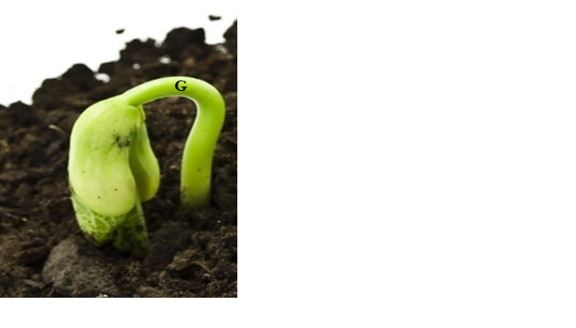 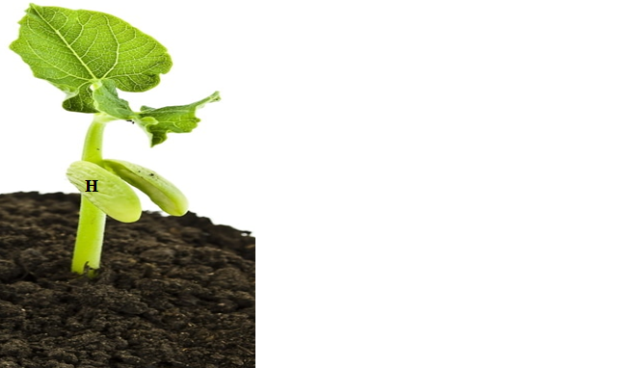 **5th day 14th day**

1. (i) Name the part label  **G**. (1 mark)

………………………………………………………………………………………………

(ii) what is the role of the part label  **G**. (1 mark)

……………………….…………………………………………………………………………………………………………………………………………………………………………….

b. Explain how the part labeled **G** straightens to make the seedling appear as shown on the 14th day? (3 marks)

.............................................................................................................................................

.............................................................................................................................................

.......................................................................................................................................................................................................................................................................................................................................................................................................................................

............................................................................................................................................

c. State three functions of the part labeled **H.** (3marks)

.............................................................................................................................................

.............................................................................................................................................

.............................................................................................................................................

.........................................................................................................................................................................................................................................................................................

d. (i) Name the type of germination exhibited by specimen L. (1 mark)

………………………………………………………………………………………………………………………………………………………………………………………….

(ii) Give a reason for your answer in d(i) above. (1 mark)

…………………………………………………………………………………………………………………………………………………………………………………………………………………………………..………………………………………………….

e. State three factors necessary for germination to take place. (3marks)

.............................................................................................................................................

.............................................................................................................................................

.............................................................................................................................................

.........................................................................................................................................................................................................................................................................................